1. The central limit theorem in my own words is that random values are added their sum will usually stay near the normal destitution.

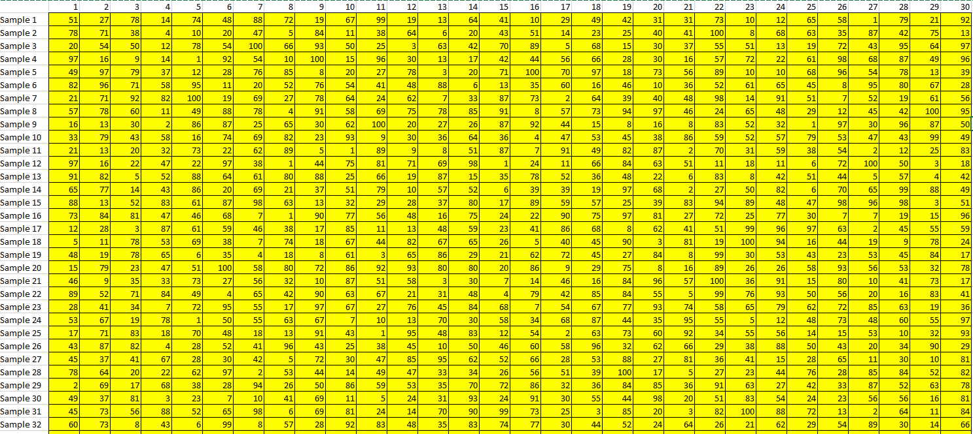

3)

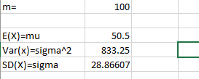

4)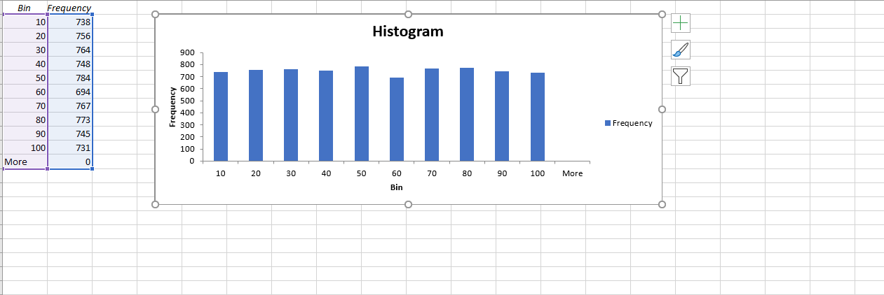

5&6)

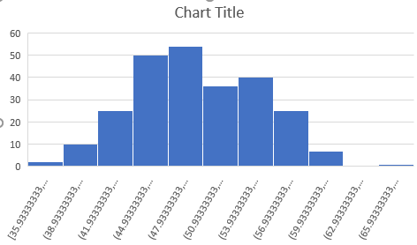

7) The central limit theorem works because they all hover around 50 and does not go too far off.

8)

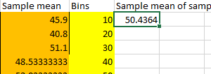

The value is around 50 so it is consistent with the theoretical expectation.

9)The standard deviation is similar to the theoretical one so the two results are consistent,

10) Based on the results that I have gotten from conducting this simulation with random values I can conclude that the central limit theorem holds and that any amount of numbers no matter the value will ultimately hover around the average point. Both histograms also show that this is the case.